(LPD) 4K DLP Splicing display unit
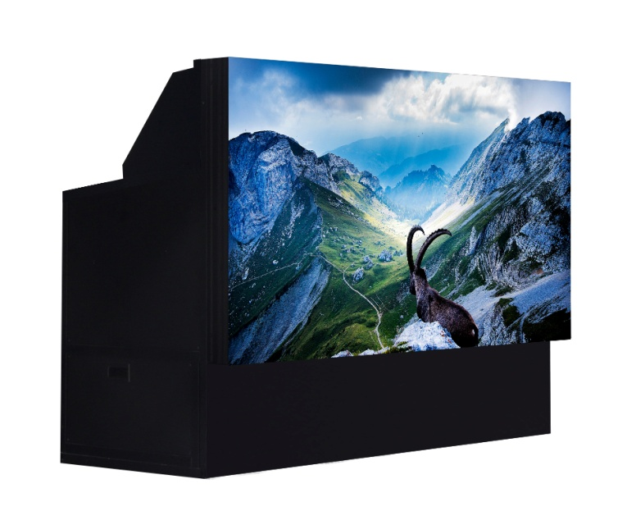
Feature：
No flickering, stable performance, comfortable viewing
● No flickering, stable performance, comfortable viewing；
● 4K@120Hz 3D signal without flickering or shaking, healthy and comfortable;；
● The thickness of the entire unit is only 860mm and occupies a smaller area；
● Ultimate seam＜0.2mm，Picture uniformity exceeds 98%；
The most comprehensive signal input and processing scheme
● Support 2D/3D/4K signal access, master-slave desktop redundant backup, and board hot swapping；
● Rich signal interfaces such as DVI/VGA, CVBS/YPbPr, HDMI1.4, 3G-SDI, DP, etc；

Energy saving, green environmental protection, and long service life
● Environmental friendly and energy-saving laser light source with a working life of 80000 hours (economic mode)；
● CCC, CE, CB, RoHS standards, green, environmental friendly, and pollution-free；

Realistic and Natural Colors
● The laser light source projector complies with the Rec.709 international color gamut standard, allowing for realistic color reproduction and suitable for long-term viewing by the human eye；
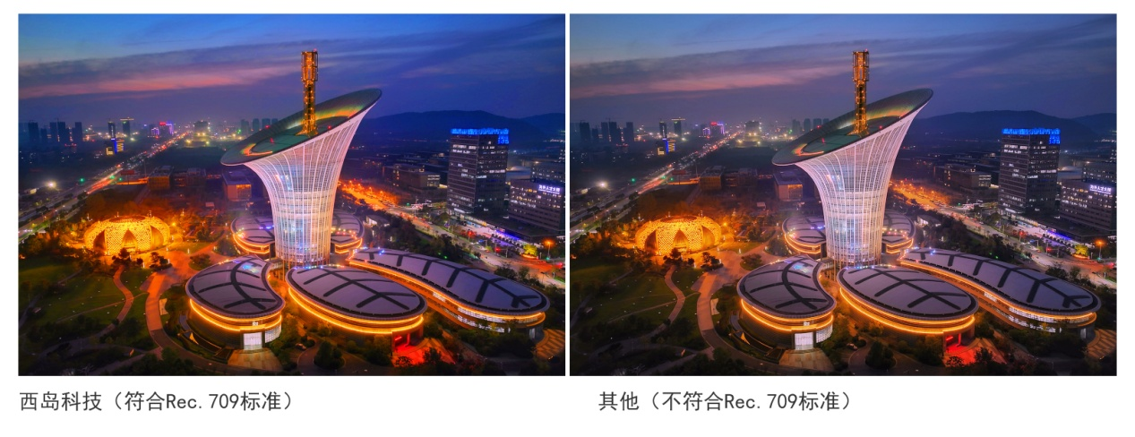
● The chromatic uniformity reaches 98%, the image is uniform and consistent, and the color presentation is more colorful and realistic；
Intelligent maintenance free technology for color and brightness
● The entire wall image is permanently balanced and consistent, without human intervention；
● Intelligent self-diagnosis, automatic business instant recovery；

- High efficiency and low power consumption
- The luminous efficiency of the laser light source reaches 12Lm/W, and the entire machine reaches 10lm/W;;
- The power consumption of the laser light source with a brightness of 1000 lumens is only 100W；
- The color of the entire wall is realistic
- Accurate segmented RGB driving current adjustment technology ensures that the brightness and chromaticity of the entire wall are completely consistent under any grayscale in the white field。
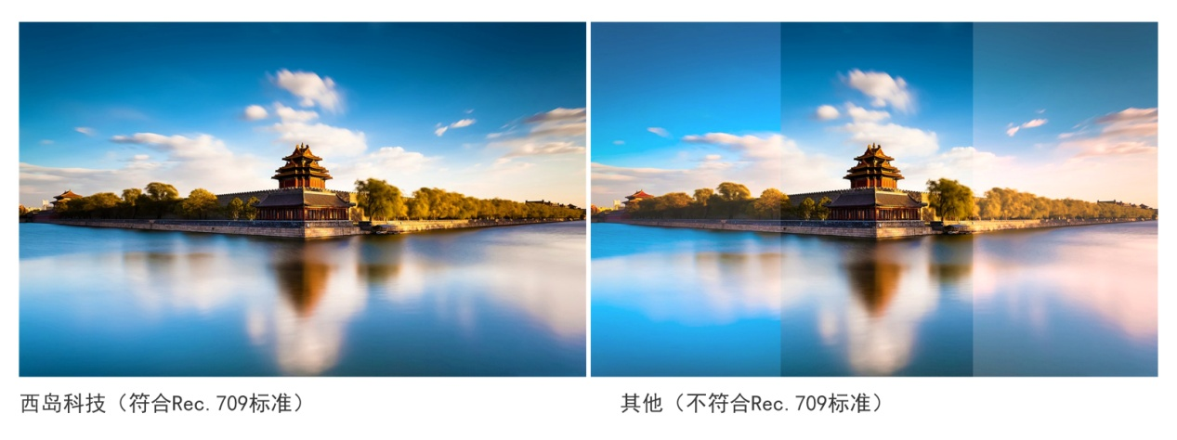
(LPD) 4K DLP Splicing large screen parameters
Parameters | Splicing unit
Display size | 60 inches, 70 inches, 80 inches
Built-in graphics processor | Zoom in and move the image horizontally and vertically
Gap | Physical splicing≤0.2mm，Flatness of whole screen splicing≤0.2mm
Color temperature | 3200K, 8000K, 91200K adjustable, RS232 mode adjustment
View angle | Horizontal greater than 178 degrees, vertical greater than 178 degrees
Screen gain | ≥2.4
Screen type | Glass resin composite screen/resin curtain (optional)
Control | RS232，RS422，RS485，Infrared remote control
Power supply | 100-240VAC 50/60Hz，1＋1 Hot backup redundant power supply optional

(LPD) 4K DLP Splicing large screen projector core parameter
Parameter |  | 4K Laser projector
Display function | Resolution ratio | 3840x2160
 | Brightness | 2500ANSI
 | Contrast ratio | 2500:1
 | Uniformity | ≥98%
 | Color grey scale level | 12bit/color
 | Color category | 16.7,24 bit True color
 | Projection size | 60”70”80”
Light source | Type | Laser light source
 | Service life | 60000hour、80000hour
 | Power | 240W，100-240VAC 50/60Hz
Signal | Input signal | Support AV, YPbPr, RGBHV, DVI , HDMI, VGA， DP
 | Output signal | DVI loop out
Working environment | Temperature | -15℃-45℃
 | Humidity | 10%-90%，No condensation
 | Reliability | Can work continuously 24 hours x 7 days
 | Noise standards | ≤22dB

